Master method

Only works if subarrays have equal size.
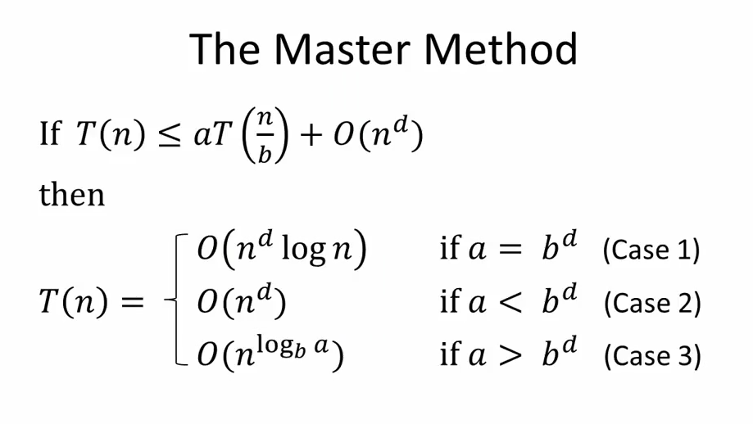
Example, in merge sort, there are two recursive calls (a=2), and b=2, that's why the running time is O(n*log(n))

In binary search, a=1, b=2, but d=0, because what's left is constant, so we are in case 1

Suppose d = 1. If you divide the array in as many recursive calls as the shrinkage of the array (two recursive calls for an array split in half, three for an array split in three), the final running cost will likely be n*log(n). If the number of recursive calls grows faster than the rate at which you cut the array, then it will likely be n^x

Consider a binary tree. a are the branches.

In other words, a is the rate at which the subproblems grow as we go deeper in the recursion, and b^d is how fast the subproblems data size shrinks (rate of work shrinkage), so it really is a balancing act between those two.

Remember n^log(a) = a^log(n)

Master method at work
Let 0<α<.5 be some constant (independent of the input array length n). Recall the Partition subroutine employed by the QuickSort algorithm, as explained in lecture. What is the probability that, with a randomly chosen pivot element, the Partition subroutine produces a split in which the size of the smaller of the two subarrays is ≥α times the size of the original array?
answer is 1-2*α.
If 0≤α≤1, the probability that the number of elements smaller than the pivot is less than αN is α. The probability that the number of elements greater than the pivot is less than αN is the same. If α≤ 1/2, then these two possibilities are exclusive.
To say that the smaller subarray is of length ≥αN, is to say that neither of these conditions holds, therefore the probability is 1-2α.

Quicksort

We are gonna use a subroutine that partitions the array around a pivot element. If we take a pivot that is like in the middle of the array, the first step of the subroutine will be to swap it with the first element to the left of the array, and then a linear swapping working to the right

Choosing a good pivot
If we choose always the first element and we are given an already sorted array, the running time will be quadratic.

Probabilistic approach
Each pair of two elements is compared only once, because in each recursive calls, the I-th pivot is excluded from all the subsequent recursive calls.
We want to determine the probable running time based on this claim, and this will be the average probability of all the elements getting compared to each other:

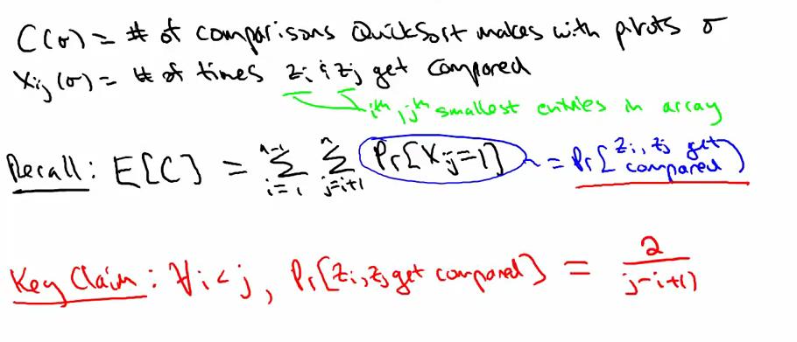
This makes sense intuitively because the probability reflects how far the two elements zi and zj are in the array. If the pivot is chosen zk with k being between I and j, zi and zj will never be compared. 2 is the sum of the probabilies that zi and zj get chosen as pivot and the lower part is the probabilty that the pivot gets chosen in between those two numbers.

Going from an algorithmic sum to the log
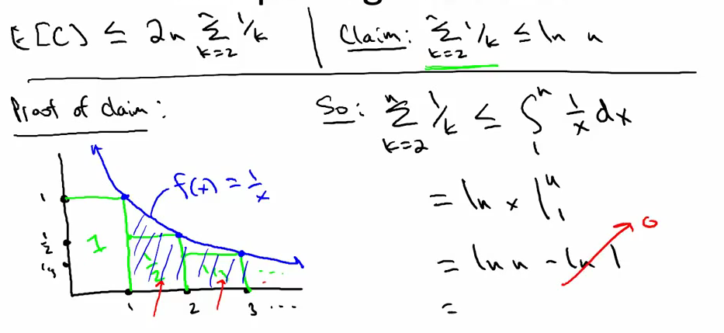
Review on probs

